Teleoperation of Robotic Arm Using Leap motion Controller and Webcam

Jonathon Burleson, Ishaan Gupta, Zejiang Zeng

**1. Abstract**

The field of robotics has undergone tremendous advancement in recent times. Today, robots are not only expected to be precise and durable but their capabilities are expected to resemble those of humans as closely as possible. In our project, we plan to implement a novel and intuitive human-robot interaction system based on a Leap Motion sensor and a robotic arm. The Leap Motion sensor will capture human hand gestures and will translate them into movement of the robotic arm. Also, computer vision will be employed to enable intelligent recognition of objects in the sensor’s view. This will enable a more natural human-robot interaction of the robotic arm and will also ensure smooth and efficient manipulation. Hence, our study will discuss and demonstrate how a human can interact with a robot through simple hand gestures. We intend to build a working prototype of the system by the end of the project. We also plan to use Webcam to capture the location or motion of objects by image processing and manipulate the arm to grasp objects.

**2.** **Introduction and Motivation**

The project selected is based on today’s growing market for smart robotic applications. There is a pressing need to incorporate a wide variety of sensors in a robotic system in order to enable robots to perform in a diverse array of applications. For e.g., computer vision can be exploited to help the robot to “see” and recognize objects in the same way as a human would.

Many world accomplishments have been made possible through the use of remote controlled technology. These robotic jobs are sometimes tasks that are too dangerous for humans. An example is a newer branch of robotics that allows human control from a distance ranging from a few feet to hundreds of miles away. Scientists have been able to successfully explore the Earth’s moon and even Mars! Doctors have the ability to operate medically on humans with greater precision. Also, military geared scientists are working on a new type of infantry designed to help save soldier’s lives. The research and the robotic possibilities are endless.

Our project mainly focuses on controlling a robotic arm which would imitate the actions of a human hand. This will be achieved using a Leap Motion sensor device which would help us to map human actions into the movement of the joints of the robotic arm. Using the data from the Leap Motion device and calculating inverse kinematics for the data using a program, we will make a robotic arm to mimic the action of a person’s arm in real‐time.

The robot could be used for virtually any application, including research or service in the medical or military fields.

The camera controlled arm also has huge impact in industry assembly line. Those arms have expanded production capabilities in manufacturing world with higher production speed and consistency. It also save workers from tedious and dull assembly line.

**3. Problem description:**

Using no-touch device to remote control a robot arm is an interesting topic in Robotics. How to extract body motions and sent those information to controller and precisely manipulate the robot is comprehensive.  Those applications will have a huge impact on entertainment and using in extreme environment.

We will use Leap Motion device to gather information of hand to control the movement of the uArm. Meanwhile, we will use Webcam and imaging processing technology to let the uArm identify the object’s location and then pick it up.

**4. Project Milestones and Accomplishments**

**Tasks:**

Part 1 (leap Motion control):

1. Using Leap Motion device and Processing software extract palm positions in 3D space(x, y, z) and use gesture recognition to control the vacuum.

     2. Send the information to Audrino and build kinematics of the uArm. Set parameters (pins, speed, position, and angle) to control the motor.

     3. Calibrate the visual position of hand and actual position of the uArm

Part 2 (Camera control):

1. Using Wedcam and Processing software to identify the color (RGB) and location (x,y) of the object.
2. Calibrate the object location in image to the location in reality.
3. Set a hard-coded (stabled height) z and manipulate the Uarm to the desired position and grasp the object.

**Accomplished:**

Part 1 (Leap motion control):

1. The hand position was captured and modeled by the Leap Motion device, using Leap motion- processing library, position data can be processed. After calibrating range of motion and declare the pump controlling gesture
2. Using inverse kinematics to calculate the desired rotational angle and speed of each motor. Vacuum can be controlled by gesture.
3. Final tuning, testing and calibrating are in process.

Part 2(Camera control):

1 .Relate to a video.library to capture an image of the object in 2D space.

1. Analyze the color (RGB) and location of the object in image and calibrate it to the actual position.
2. Using inverse kinematics to calculate the desired rotational angle and speed of each motor.
3. Final tuning, testing and calibrating are in process.

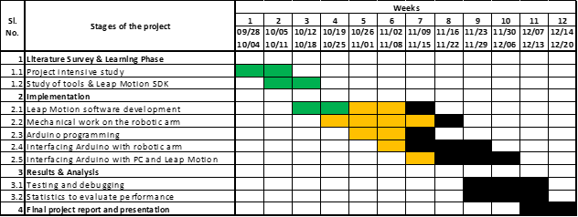

**https://lh6.googleusercontent.com/huel9E4SDaj3-tpFk9_PsBdLSYAqQPfbQ6KHa5pct6WI-q5I50SKJBLi77CrU2vJvLpKe_8N8xq5YmDimSEV9fX5ZXWfAD_70lfP4YwZ4a2UAVviAsRcv9Ho9mwJC_DKxGaeuqdw**

In terms of project progress, we are largely on track and we have achieved most of our planned goals with a very slight delay. We are confident that we will be able to complete the bulk of the technical work with on the next 3 weeks which will give us ample time for testing and to explore some of our future goals.

1. We have completed a thorough literature survey and study of tools (LeapMotion SDK, Arduino, Processing library, OpenCV) which will enable us to get up to speed on the software development work that is remaining on the project.
2. Leap Motion software development work and Camera Controlling has reached roughly 70% completion and we are confident of completing the work ahead of time.
3. Mechanical work and Arduino programming on the robotic arm has also been started and we will devote most of our time to that once we finish calibration.
4. Testing and debugging are yet to be started but we in course our project work, we started to realize and formulate some test plans that we will implement once we are nearing completion.

**Results:**

**Leap Motion:**

Using Leap Motion-Processing Library and API Reference provided by Leap Motion developers. Position and gesture can be read and recognized by Leap Motion and those data will be sent to Arduino through Processing. Processing code is done.

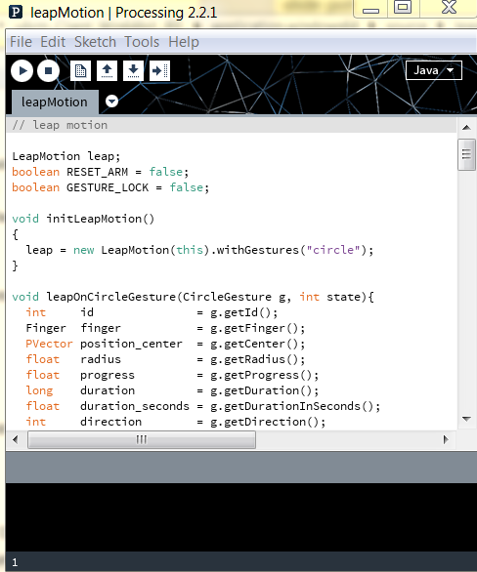

Figure 1. Leap Motion in Processing

And testing, tuning and Calibrating are still need to be done.

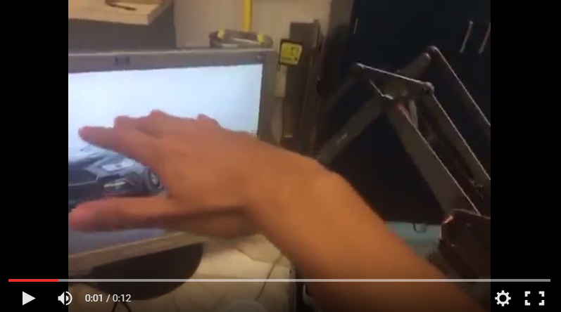

Figure 2. uArm controlled by Leap Motion

A pen would be attached on the pen-holder to write words when people write in air.

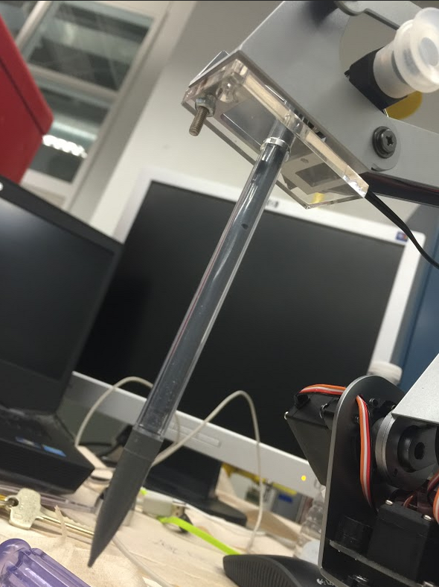

Figure 3. Pen Holder attached on uArm

Using the uArm-library provided by the Ufactory company, Arduino code for driving the motors and pump are done as figure 4.

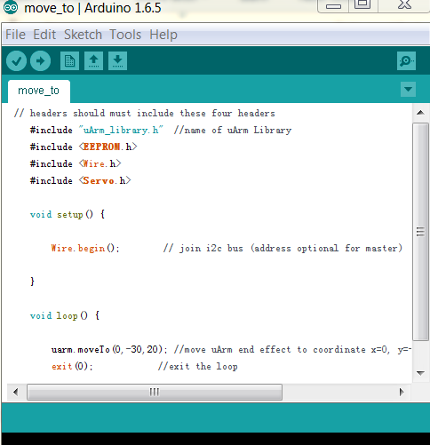

Figure 4. Arduino code for uArm

**Camera Control:**

Using processing and webcam (camera on Laptop), video or image can be captured in real-time. The camera will be placed above the uArm and identify the location of the object by image processing. Known the position of object, the uArm will grasp it and place it to another desired place.

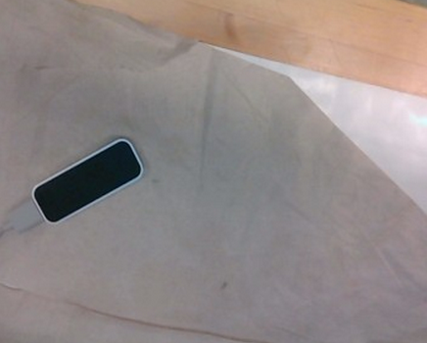

Figure 5. Image took by the webcam

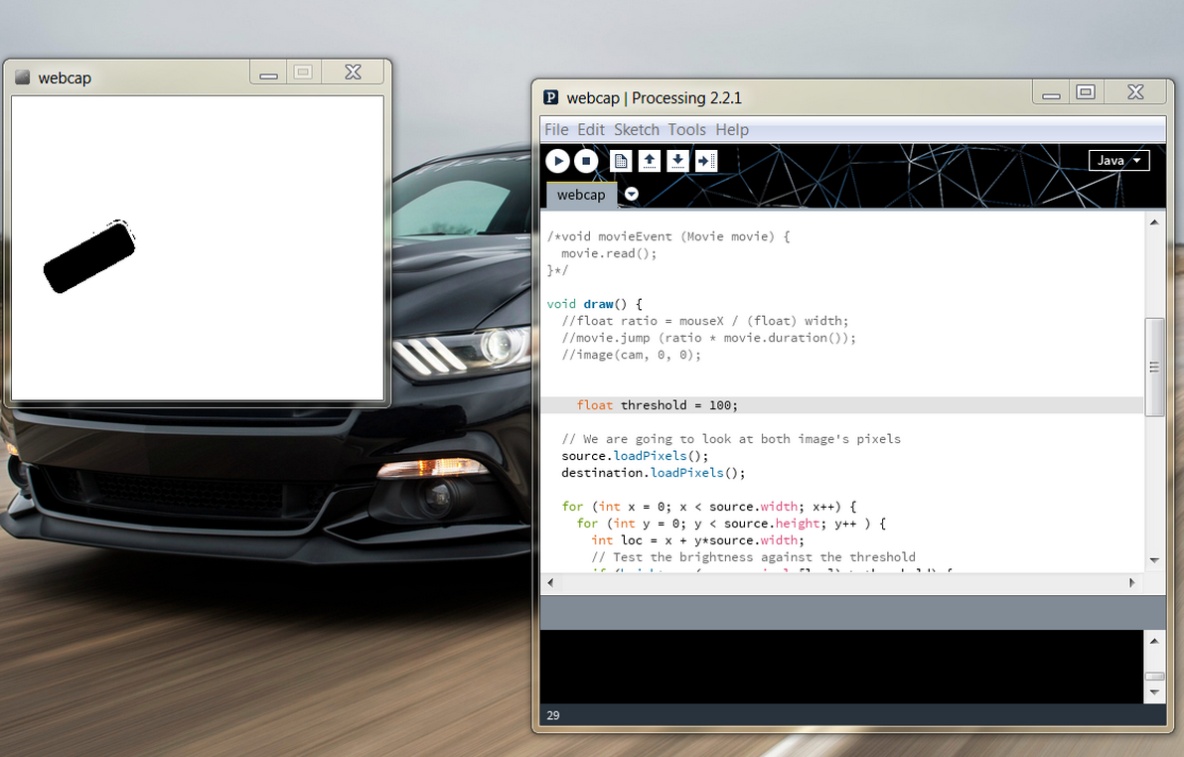

Figure 6. Image Processing and code in Processing

Identify the color and locations of pin pang balls:

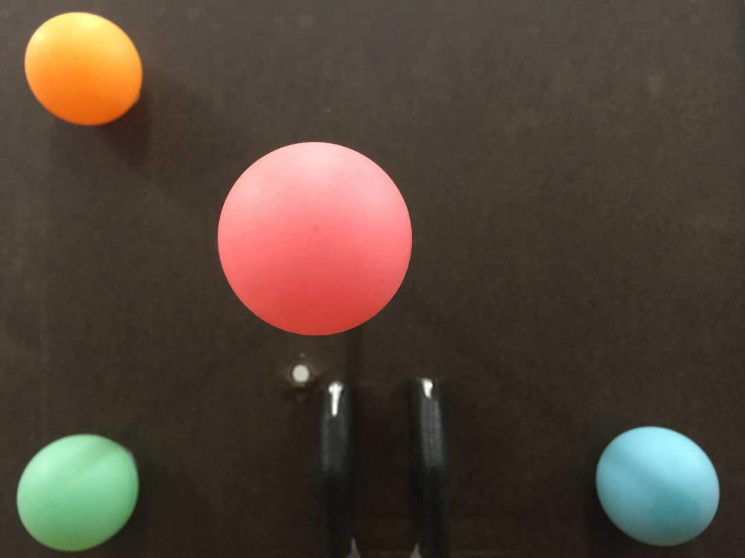

Figure 7. Pin pang ball with red, green and blue

**Results for locating the red, green and blue balls**

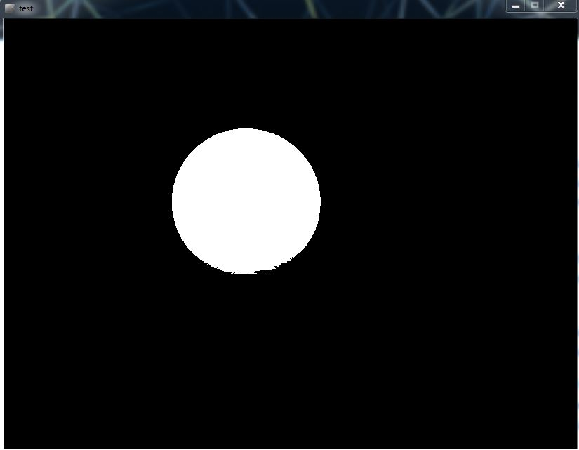

Figure 8. Location of the red ball

Center of mass for the red ball is (344,259).

And the location of the green ball is shown in figure 9:

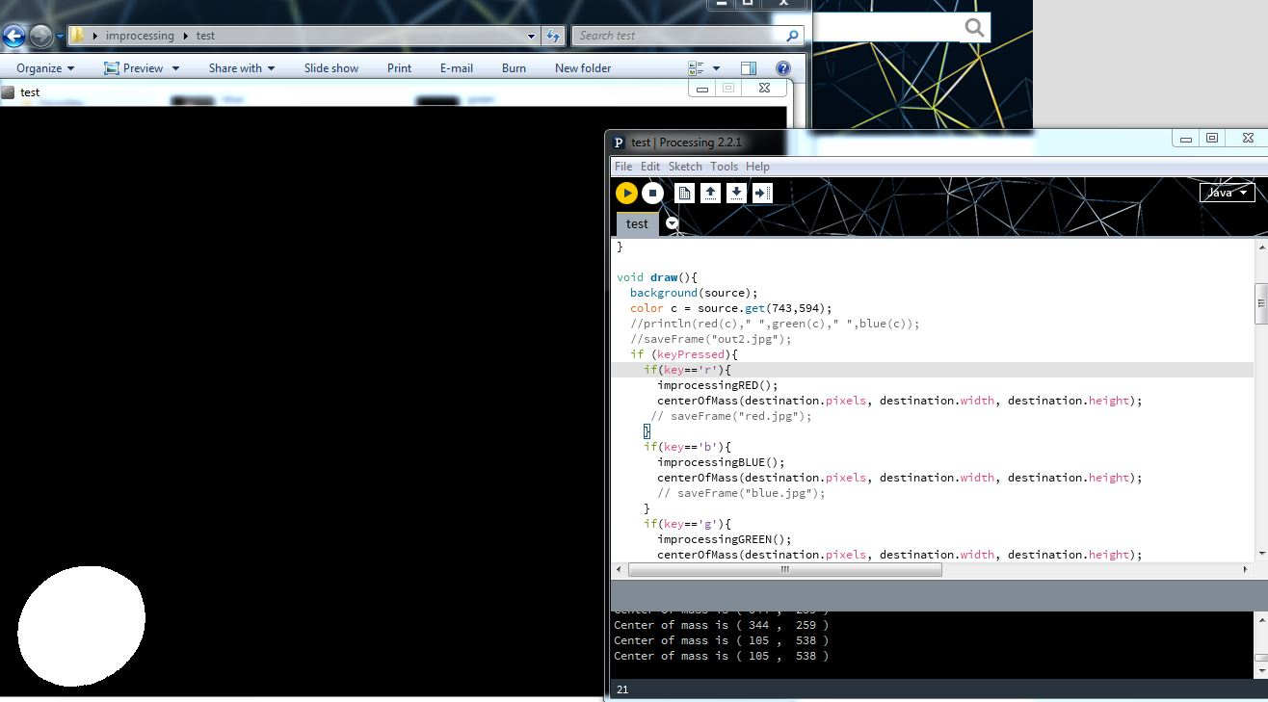

Figure 9. Location of the green ball

Its center of mass is (105,538). Those number are pixel number, which will be calibrated to actual dimensions.

**Conclusions**

We can confidently state that our project is on track and we will be able to complete the bulk of the technical work on time.

**Reference:**

1. Bassily, D., et al. "Intuitive and adaptive robotic arm manipulation using the leap motion controller." *ISR/Robotik 2014; 41st International Symposium on Robotics; Proceedings of*. VDE, 2014.

2. Leap Motion | Mac & PC Motion Controller for Games, Design, & More. 2014. Available at: http://www.leapmotion.com. [Accessed January 2014].

3. Marin, Giulio, Fabio Dominio, and Pietro Zanuttigh. "Hand gesture recognition with leap motion and kinect devices." *Image Processing (ICIP), 2014 IEEE International Conference on*. IEEE, 2014.

4. Vikram, Sharad, Lei Li, and Stuart Russell. "Handwriting and Gestures in the Air, Recognizing on the Fly." *Proceedings of the CHI*. Vol. 13. 2013.

1. Weichert, Frank, et al. "Analysis of the accuracy and robustness of the leap motion controller." *Sensors* 13.5 (2013): 6380-6393.
2. Oh, Paul Y. "A template for real-time image processing development: Windows-based PCs and webcams for computer vision research and education."*Robotics & Automation Magazine, IEEE* 12.4 (2005): 65-74.
3. Nahvi, Ali, et al. "Calibration of a Parallel Robot Using Multiple Kinematic Closed." (1994).
4. Bergerman, Marcel. *Dynamics and control of underactuated manipulators*. Diss. CARNEGIE MELLON UNIVERSITY, 1996.
5. Ishikawa, Jun, Kazuhiro Kosuge, and Katsuhisa Furuta. "Intelligent control of assembling robot using vision sensor." *Robotics and Automation, 1990. Proceedings., 1990 IEEE International Conference on*. IEEE, 1990.
6. Han, Sung-Hyun, et al. "Real-Time control of an industrial robot using image-based visual servoing." *Intelligent Robots and Systems, 1999. IROS'99. Proceedings. 1999 IEEE/RSJ International Conference on*. Vol. 3. IEEE, 1999.
7. Xin-sheng, D. O. N. G., Z. H. A. N. G. Chuan-si, and L. I. Xin. "Status and Developmental Trend of the Assembling Robot [J]." *Modular Machine Tool & Automatic Manufacturing Technique* 8 (2007): 002.
8. Kumar, Vijay. "Instantaneous kinematics of parallel-chain robotic mechanisms." *Journal of Mechanical Design* 114.3 (1992): 349-358.
9. Nahvi, Ali, et al. "Calibration of a Parallel Robot Using Multiple Kinematic Closed." (1994).